Sardar Patel Education Trust, Anand

N.S.Patel Circle, Bhalej Road, Anand

Application form for the post of Principal in
N H PATEL COLLEGE OF EDUCATION, ANAND

NOTE :

Affix

Recent Passport Size

Photo

- The application should be submitted along with attested copies of the relevant certificates, mark sheets, testimonials etc.

- Additional sheets of paper may be attached if the space provided against any item is insufficient.

- Minimum Qualification and Experience as per norms of UGC Regulation-2018 and Gujarat Government rules.

- Candidate is required to mention e-mail address and Mobile number.

- Candidate is required to fill in the form for calculating API’s as per Appendix – III Table II.
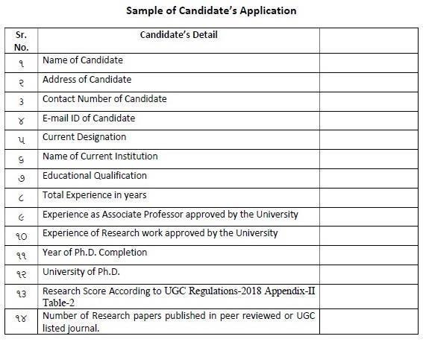

5

- Name in full (in Block Letters) :

Shri
Smt._______________________________________________________________
Kum. (SURNAME) (NAME) (FATHER’S / HUSBAND’S NAME)

- Full address for correspondence:

Present

______________________________

______________________________

__________________Pin__________

Mob./ Phone No. :________________

Permanent

________________________________

________________________________

__________________Pin____________

Phone No.:_______________________

E-Mail ID:___________________________________________________________

AADHAR Number:___________________________________________________

- Gender: Male/Female_____________ Date of Birth: __________(DD/MM/YY)
Category: General/SC/ST/OBC Age:________________________
Nationality: __________________ Mother tongue__________________

- Place of Birth : Town / Village:_____________________ Tal.___________________

Dist.: ___________________State__________________
5. Languages Known :

Read

Write

Speak

6. Educational Qualifications: (Beginning with HSC Exam.)

Examination
Passed

University /
Board

Year of
Passing

Percentage

Subjects /
Discipline

6

7. Details of Experience: (After obtaining the basic Degree)

Name & Address of
the

Employer/Institute

Designation | Period of
of the post |  | Service
held | From: |  | To

Nature of
Service

Total Salary drawn p.m. (Rs.)

- Research experience with details of research papers and articles published:

___________________________________________________________________

___________________________________________________________________

___________________________________________________________________

___________________________________________________________________

- Details of Publications, if any: Book / Monographetc.
Title | Month / Year | Name of Publisher

- Details of any other innovations / activity involved during professional career:

___________________________________________________________________

___________________________________________________________________

___________________________________________________________________

___________________________________________________________________

___________________________________________________________________

7

- Present Designation:__________________ Institute:_______________________

Date of Joining present post:_________________

Present Pay Rs. _________Pay Band_____________________AGP__________

Total emoluments, pm. Rs. ______________________

- List of Testimonials / Certificates / Mark sheets /Degree Certificates/ IT Return of Last five Years/ Service book copy with 6000 to 9000 GP assign by authorized officer/NOC/Experience Certificates/All OP and RC Certificates/Papers/Books front page of which copies are attached with the application:

1. 5.

2. 6.

3. 7.

4. 8….

_________________________________________________________________________

13. | Whether the candidate is convicted for | Yes / No
 | any offence under any Civil / Criminal Law?
 | (If yes, provide the details)
14. | Whether any Civil / Criminal Case is pending? | Yes / No
 | (If yes, provide the details)

I hereby declare that the information given above is true and correct to the best of my knowledge, information and belief.

PLACE:__________________

DATE:___________________

____________________________
Signature of the Candidate

8

(NOC) ENDORSEMENT OF THE CURRENT EMPLOYER (IF APPLICABLE)

- The application of ______________________________________is hereby forwarded with the remarks that we have No Objection to her/his application being considered by Sardar Patel Education Trust, Anand for the post of Principal in N H Patel College of Education, Anand-388001 (Gujarat)

- Certified that the information given by the applicant in this application form has been checked / verified and found to be correct with reference to her/his service records.

- It is certified that no vigilance case is pending/contemplated against the applicant and she/he is clear from vigilance angle.

Signature of the Employer
(with office seal)

